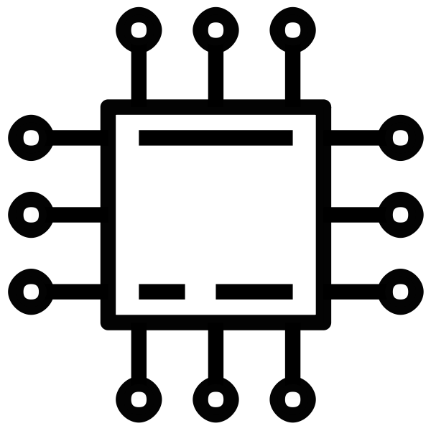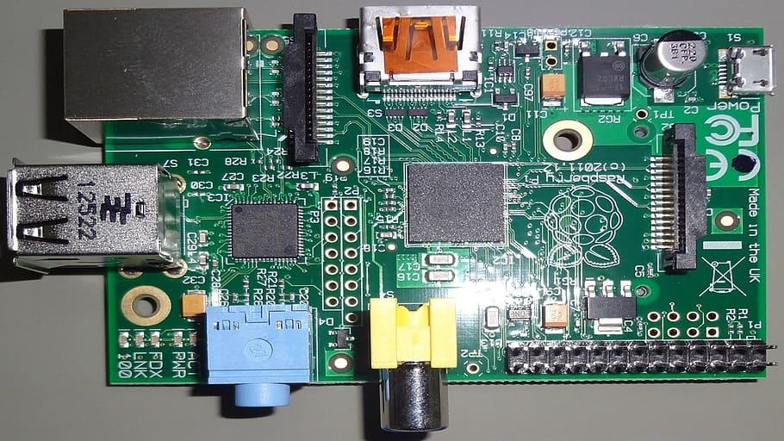

BUSIREDDY JAGADEESHWAR REDDY

BU21EECE0100177

REPORT ON EMBEDDED C ACTIVITY

1] Write a program to count no. of bits that are set in a given binary

pattern.

Code:

#include <stdio.h>

int countSetBits(unsigned int num)

{

int count = 0;

while (num)

{

count += num & 1; num >>= 1;

}

return count;

}

int main()

{

unsigned int num = 0b10101010;

printf("Number of set bits: %d\n", countSetBits(num));

return 0;

}

**Output**: Number of set bits: 4

2] Write a program to set the 5th and 12th bits in a 16-bit unsigned integer

**Code**:

#include <stdio.h>

unsigned int setBits(unsigned int num, int pos1, int pos2)

{

unsigned int mask = (1 << pos1) | (1 << pos2);

return num | mask;

}

int main()

{

unsigned int num = 0b00000000; num = setBits(num, 5, 12);

printf("Modified number: %d\n", num);

return 0;

}

**Output**: Modified number: 4864

3] Write a program to clear 6th and 19th bits in a 32-bit unsigned integer.

**Code**:

#include <stdio.h>

unsigned int clearBits(unsigned int num, int pos1, int pos2)

{

unsigned int mask = ~(1 << pos1) & ~(1 << pos2);

return num & mask;

}

int main() { unsigned int num = 0b1111111111111111111;

num = clearBits(num, 6, 19);

printf("Modified number: %u\n", num);

return 0;

}

**Output**: Modified number: 524287

4] Write a program to flip even positioned bits in a 16-bit unsigned integer

**Code**:

#include <stdio.h>

unsigned int flipEvenBits(unsigned int num)

{

unsigned int mask = 0xAAAA; // Binary pattern with even bits set

return num ^ mask;

}

int main()

{

unsigned int num = 0b1010101010101010; // Example 16-bit unsigned

integer

num = flipEvenBits(num);

printf("Modified number: %d\n", num);

return 0;

}

**Output**: Modified number: 2730

5] Given an unsigned 32-bit integer holding packed IPv4 address, convert it

into "a. b. c. d" format.

**Code**:

#include <stdio.h>

int countSetBits(unsigned int num)

{

int count = 0;

while (num)

{

count += num & 1;

num >>= 1;

}

return count;

}

int main()

{

unsigned int num = 0b10101010; // Example binary pattern

printf("Number of set bits: %d\n", countSetBits(num));

return 0;

}

**Output**: Number of set bits: 4

6] Convert MAC address into 48-bit binary pattern

**Code**:

#include <stdio.h>

void unpackIPAddress(unsigned int ip)

{

int a, b, c, d;

a = (ip >> 24) & 255;

b = (ip >> 16) & 255;

c = (ip >> 8) & 255;

d = ip & 255;

printf("Unpacked IP address: %d.%d.%d.%d\n", a, b, c, d);

}

int main()

{

unsigned int packedIP = 3232235777; // Example packed IP address

unpackIPAddress(packedIP);

return 0;

**Output**: Unpacked IP address: 192.168.1.1

7] Convert 48-bit binary pattern as MAC address

**Code**:

#include <stdio.h>

void macToBinaryPattern(char *mac)

{

unsigned long long int binary = 0;

sscanf(mac, "%2hhx:%2hhx:%2hhx:%2hhx:%2hhx:%2hhx", (unsigned char

*)&binary,

(unsigned char *)&binary + 1, (unsigned char *)&binary + 2,

(unsigned char *)&binary + 3, (unsigned char *)&binary + 4,

(unsigned char *)&binary + 5);

printf("Binary pattern: %llx\n", binary);

}

int main()

{

char mac[] = "12:34:56:78:9a:bc"; // Example MAC address

macToBinaryPattern(mac);

return 0;

}

**Output**: Binary pattern: 123456789abc

8] Convert 48-bit binary pattern to MAC address.

**Code**:

#include <stdio.h>

void binaryPatternToMac(unsigned long long int binary)

{

printf("MAC address: %02llx:%02llx:%02llx:%02llx:%02llx:%02llx\n",

(binary >> 40) & 0xFF, (binary >> 32) & 0xFF, (binary >> 24) & 0xFF,

(binary >> 16) & 0xFF, (binary >> 8) & 0xFF, binary & 0xFF);

}

int main()

{

unsigned long long int binary = 0x123456789abc; // Example binary pattern

binaryPatternToMac(binary);

return 0;

}

**Output**: MAC address: 12:34:56:78:9a:bc